LAB 2
EXERCISE 1
File: Circle.java
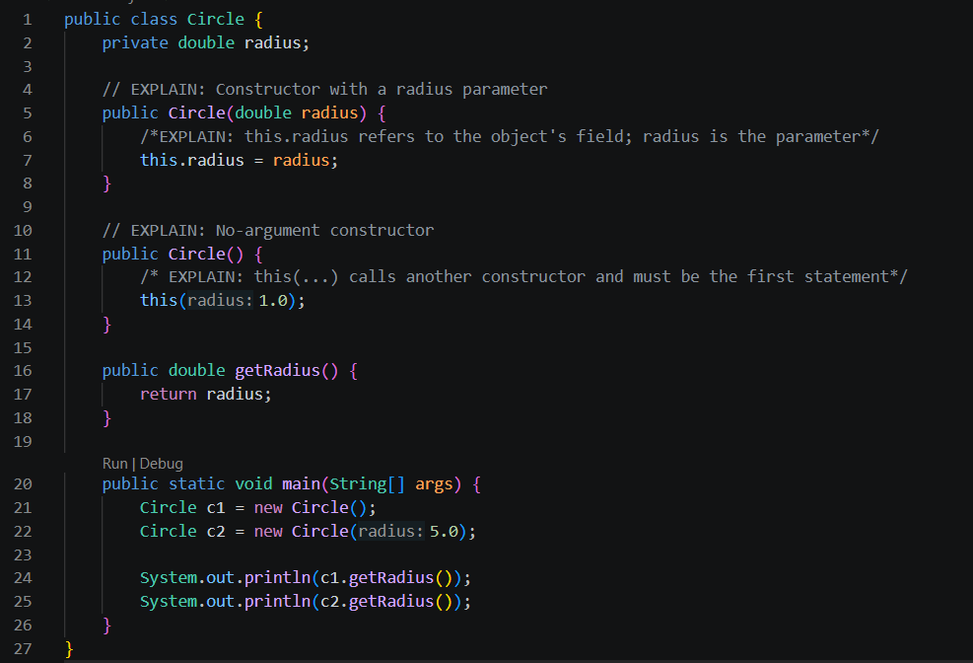

Output:


EXERCISE 2
File: Circle.java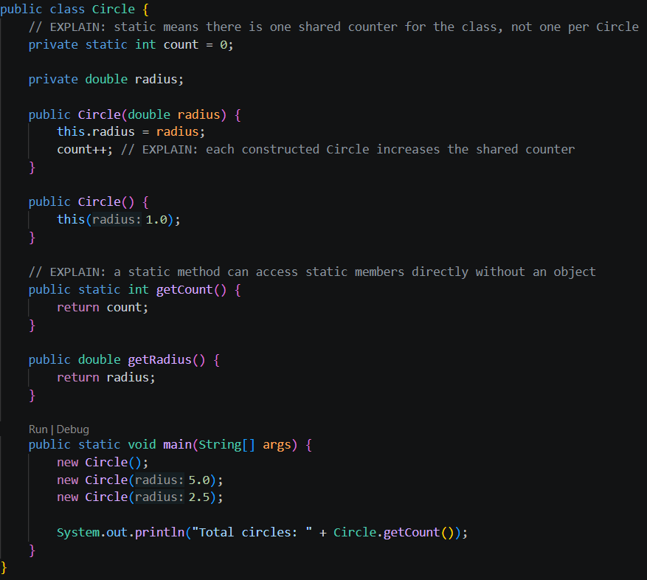

Output:

EXERCISE 3
File: Employee.java
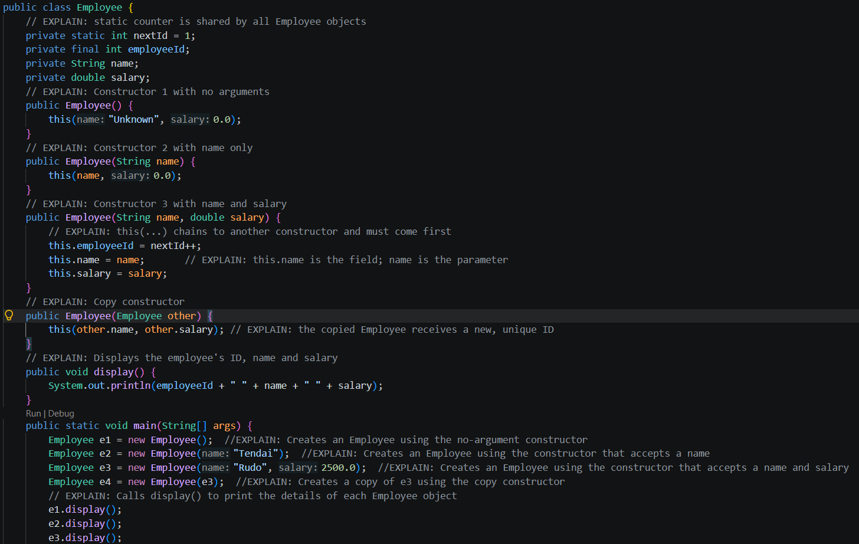

Output:
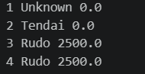

EXERCISE 4
File: InitOrder.java
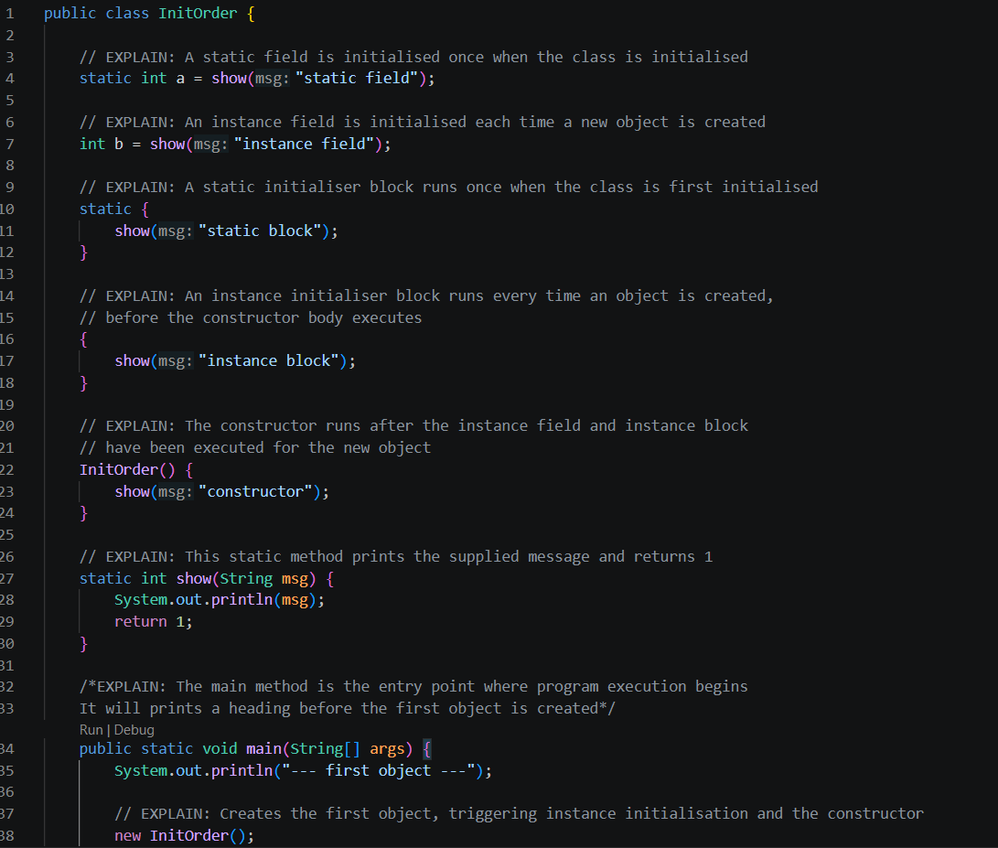
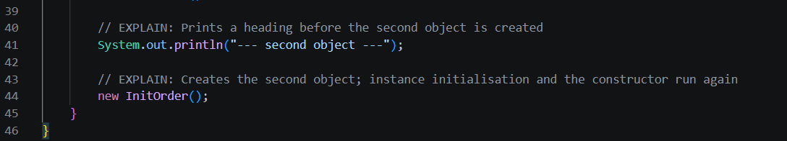

Output:
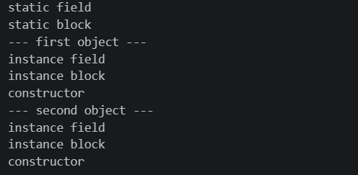

EXERCISE 5
File: Temperature.java
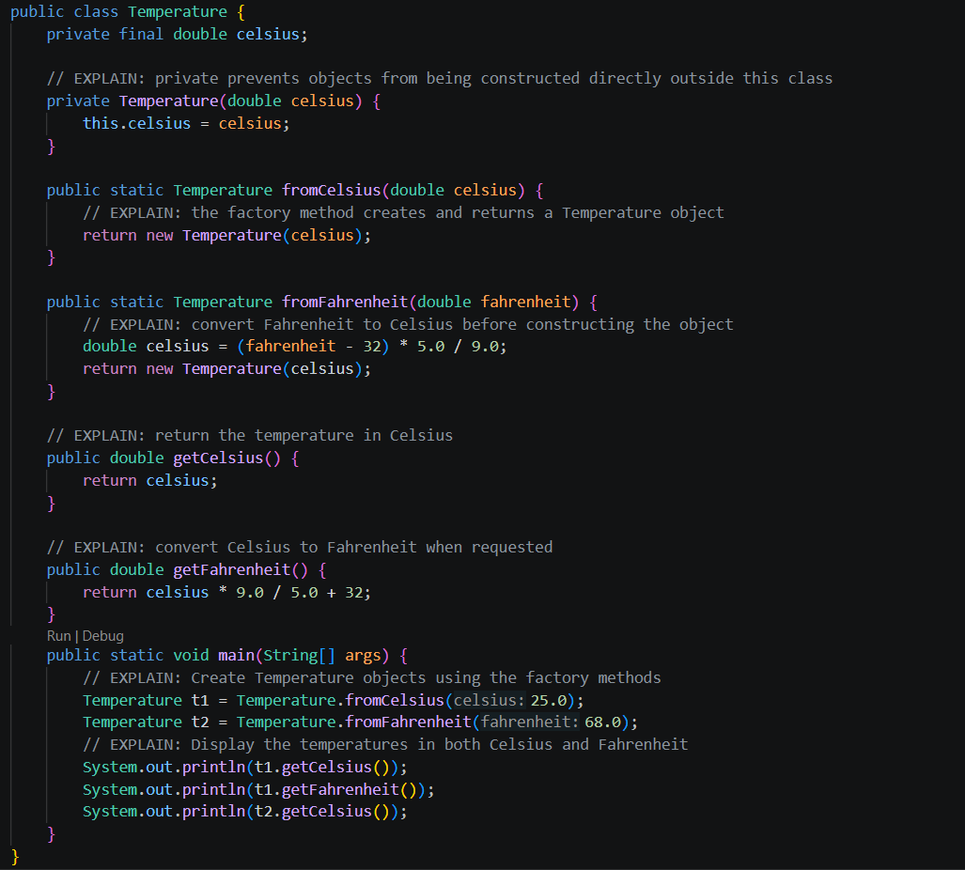
Why are static factory methods clearer than overloaded constructors?
Static factory methods have descriptive names that indicate the unit being supplied. For example, Temperature.fromCelsius(25) clearly accepts Celsius, while Temperature.fromFahrenheit(77) clearly accepts Fahrenheit. If both were overloaded constructors accepting a double, the calls would look alike and would not clearly communicate which unit the value repressents. The private constructor also ensures that objects are created through the named factory methods.

